
Oct – 2026
ASSIGNMENT – 2
Course Code : CSA4307
Course Name : INTERNET PROGRAMMING
M.ATCHAYA
192411088
Max Marks: 50
Answer all the Questions

1 | Develop a JavaScript program using DOM manipulation and Regular Expressions to validate student name, email ID, mobile number and password during online registration. Display appropriate error messages without reloading the webpage. | (10) | (CO2) | (BL5)
2 | An e-commerce dynamic product search webpage using JavaScript DOM and AJAX for to Retrieve product details in JSON format from the server and display the matching products dynamically as the user enters a product name. | (10) | (CO2) | (BL4)
3 | Discuss the significance of the XMLHttpRequest object, its ready State properties and callback methods. Illustrate the working of AJAX using a suitable JavaScript program . | (10) | (CO2) | (BL3)
4 | An engineering college plans to develop a Student Management System using TypeScript to manage student information, including name, register number, department and marks. Develop a TypeScript program using a class and object to represent student details. Include properties, a constructor and a method to display student information. | (10) | (CO2) | (B4)
5 | Develop a JavaScript-based form validation system for an online banking application. Use Regular Expressions to validate account number, mobile number and email ID. | (10) | (CO1) | (BL4)

ANSWERS
QUESTION 1

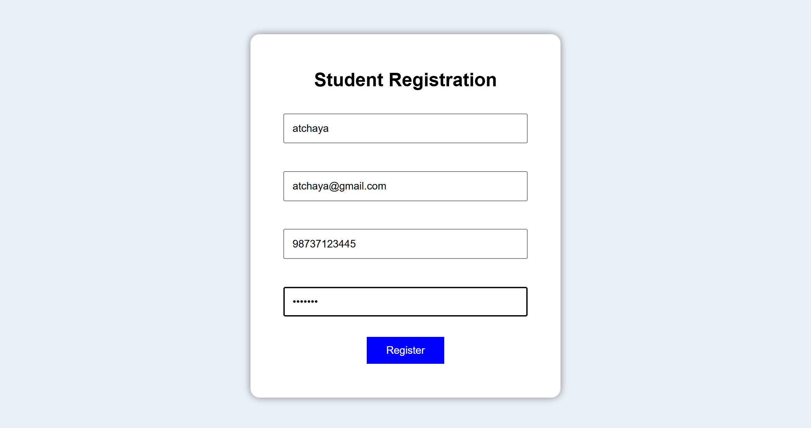

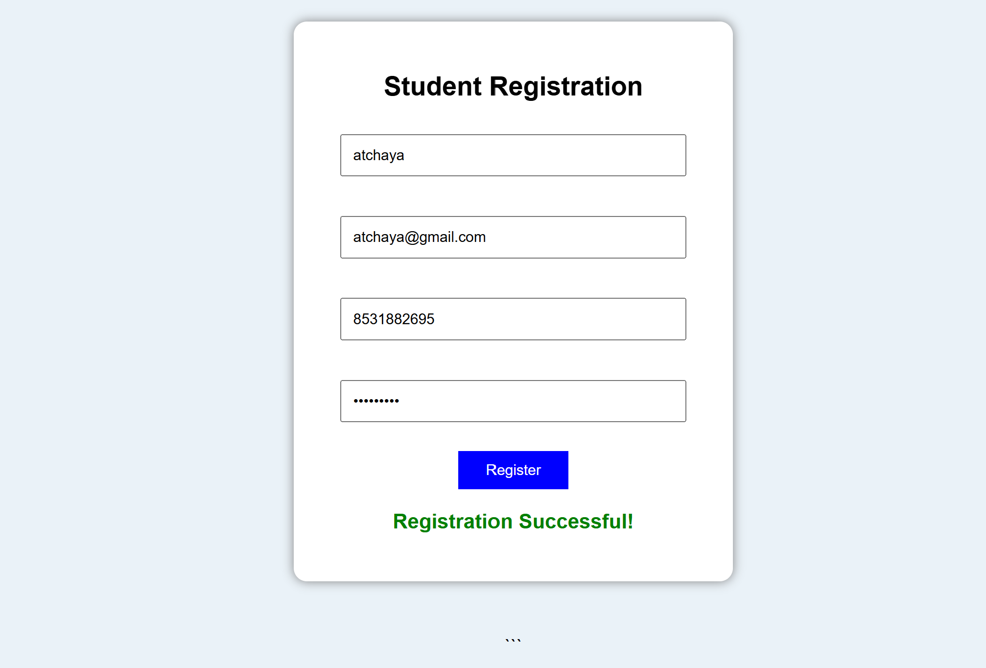

QUESTION 2


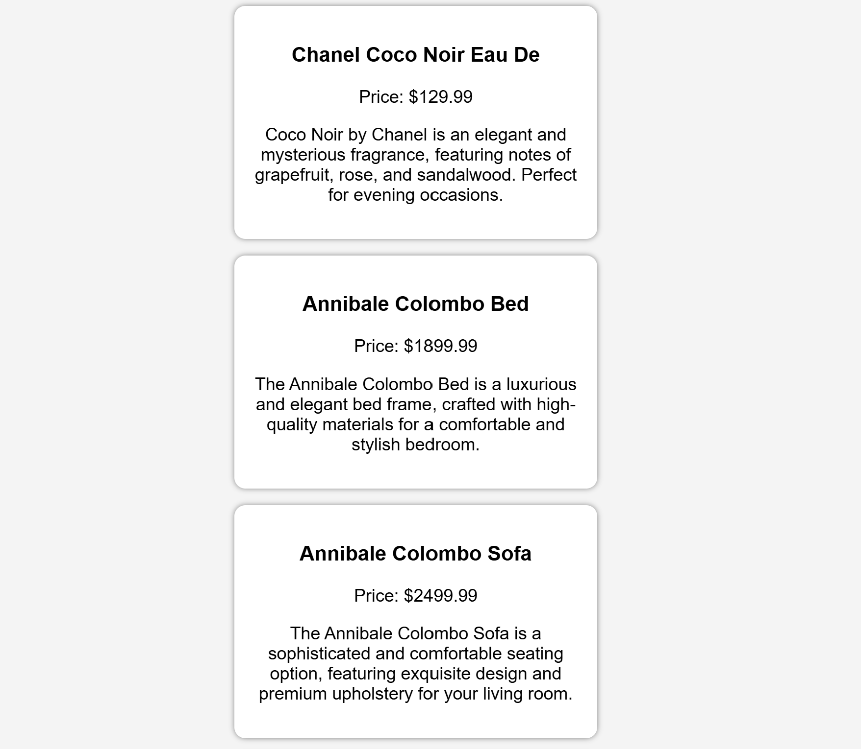

QUESTION 3
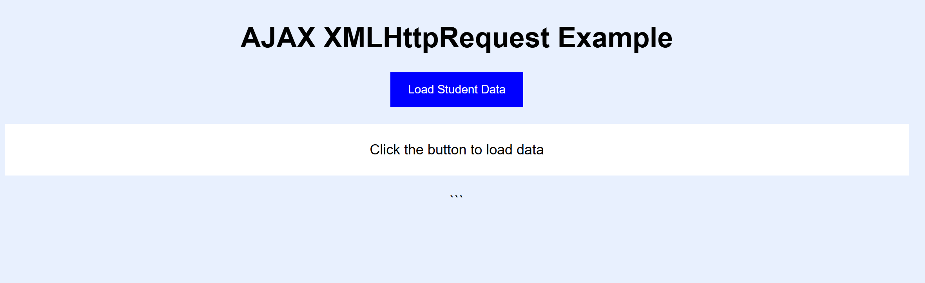



QUESTION 4

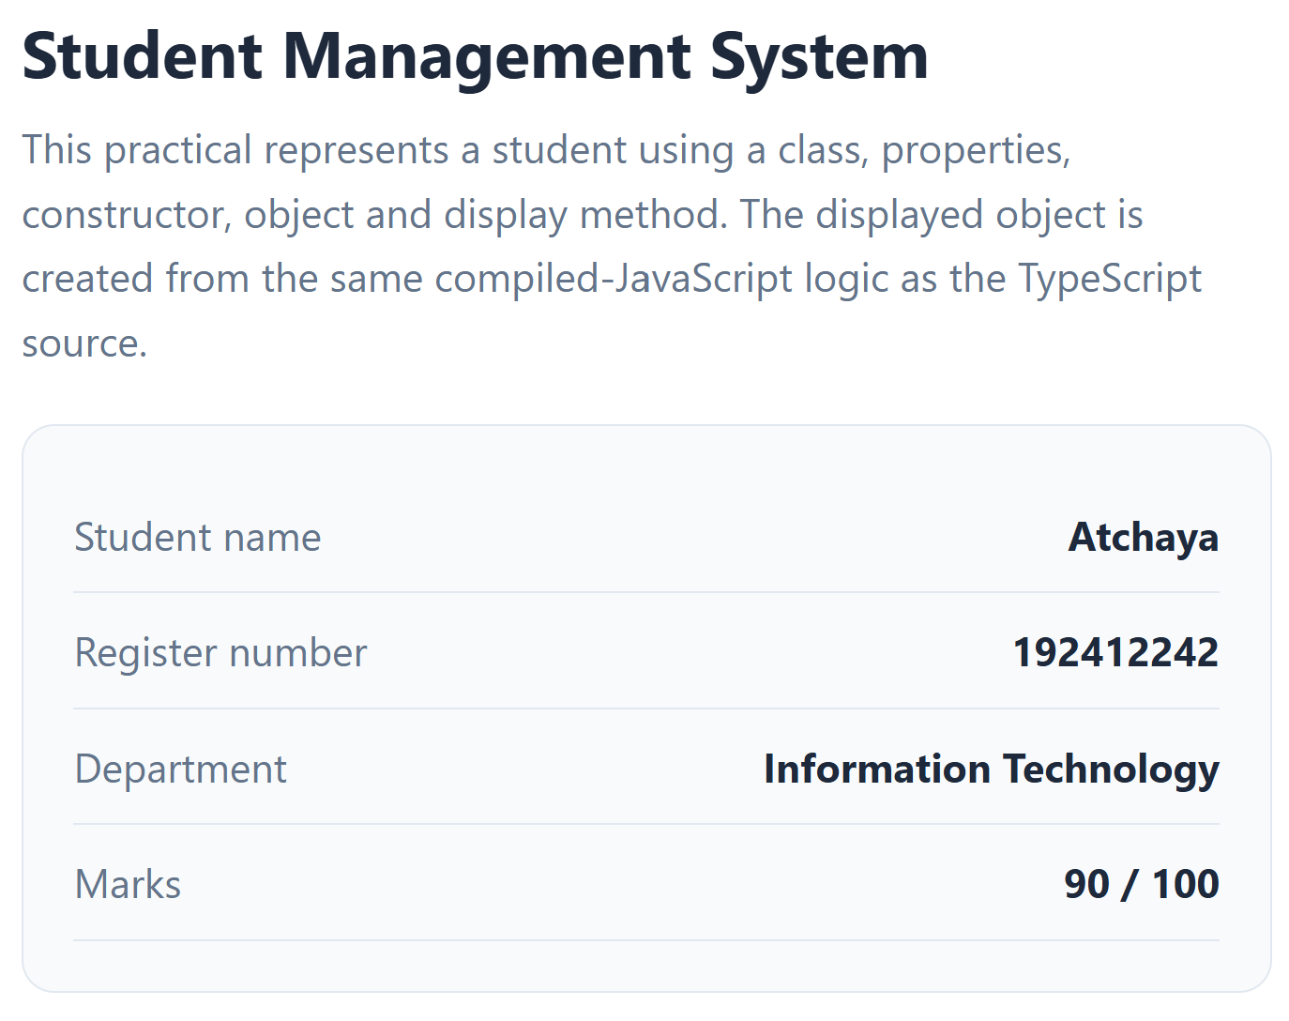

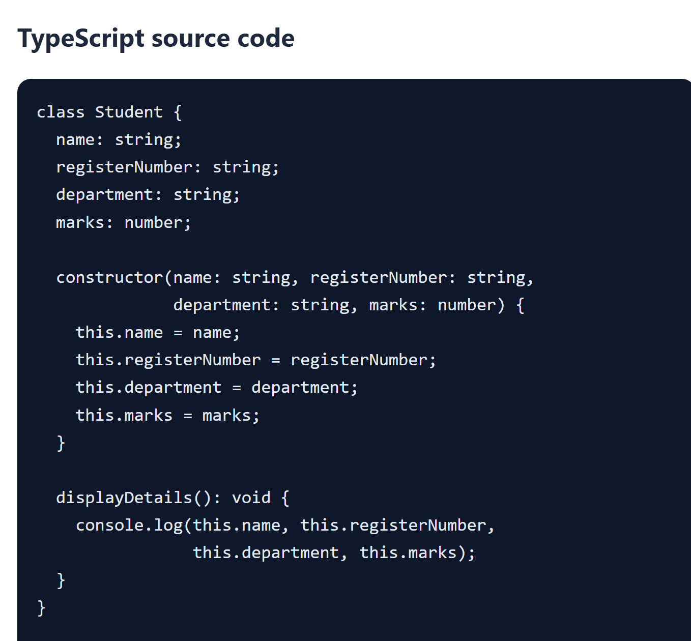

QUESTION 5



